# AMC Bridge Education Project

* Target CAD system: Solid Works 2015 x64
* Project solution: Visual studio 2015
* Platform: Windows
* .Net FW: Framework 4.0

Project Logic



Program folder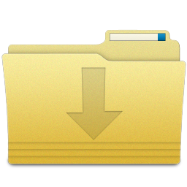

Project installer

Functions:

* Install application
* Registered new add-in
* Integrate in SW 2015 x64

Windows register

* Add add-in to register by GUID

New Tab in SW

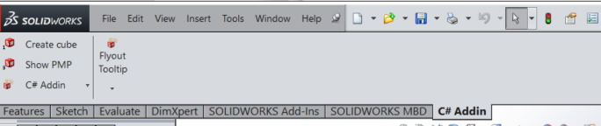



User SW Part Doc

Build model

* Build 3d shaft by parameters

Add-in opening

* Open main window
* Get SW app

Get values

* Get values and properties from main widow

X

Add-in interface

(Main Window)

Add-in running

* Pres Button at SW add-in tab